**Member Management Demo Script LS BC Retail**

*FUNCTION: Membership Management*

*Date: 07 February 2023*

Version: 1.0NaviWorld_Logo

Prepared by:

**NaviWorld Myanmar Business Solutions Co., Ltd**

No. (262), Bargayar Road, Myaynigone, Sanchaung Township, Yangon Division, Myanmar

(+95 9 453366116, +95 9 453366117, +95 1 527692)

email_signature_image

Contents

[1 Introduction 1](#_Toc127621635)

[1.1 Prerequisites 1](#_Toc127621636)

[2 Member Management 6](#_Toc127621637)

[2.1 Creating a Member Club 7](#_Toc127621638)

[2.2 Creating a Member Scheme 15](#_Toc127621639)

[2.3 Creating a Member Account 19](#_Toc127621640)

[2.4 Creating a Member Contact 25](#_Toc127621641)

[2.5 Point Setup 29](#_Toc127621642)

[2.6 Attributes for Club 32](#_Toc127621643)

[2.7 Attributes for the Account 36](#_Toc127621644)

[3 General Functions 39](#_Toc127621645)

[3.1 Creating Cards 39](#_Toc127621646)

[3.2 Assigning Cards 42](#_Toc127621647)

[3.3 Active Cards 43](#_Toc127621648)

[3.4 Blocking / Unblocking Accounts 44](#_Toc127621649)

[3.5 Member Point Journal 49](#_Toc127621650)

[3.6 Member Point Transfer Journal 54](#_Toc127621651)

[3.7 Transfer Value Factor 56](#_Toc127621652)

[3.8 Member Point Entries 60](#_Toc127621653)

[3.9 Member Point Statistics 63](#_Toc127621654)

[4 POS Functions 66](#_Toc127621655)

[4.1 Points Generated by POS Sale 66](#_Toc127621656)

[4.2 Points Used as Payment in the POS Sale 71](#_Toc127621657)

[5 Periodic Activities 76](#_Toc127621658)

[5.1 Upgrade / Downgrade Management 76](#_Toc127621659)

[5.2 Expire Member Point Entries 80](#_Toc127621660)

[5.3 Update Member Information 81](#_Toc127621661)

[6 Member Campaign 84](#_Toc127621662)

[6.1 Creating Member Campaign 84](#_Toc127621663)

[6.2 The Campaign’s Attribute 90](#_Toc127621664)

[6.3 Total Offer and Campaign Attribute 94](#_Toc127621665)

[6.4 Campaign’s Attribute Entries 102](#_Toc127621666)

[7 Member Management with Offers 104](#_Toc127621667)

# Introduction

The purpose of this Demo script document is to give an overview of the LS BC Member Management. This is done by setting up examples based on the demo data with LS BC.

Member management has functionality of member clubs that can be of different types, member clubs as loyalty and member clubs as staff clubs for a company.

This document is intended for LS Retail partners; their sales representatives/consultants who need to know the system and can to demonstrate it to clients.

The Demo script consists of three columns

**What to DO- Step by Step:** Instructions for the user what to do

**Explanation:** Explanation for the user of what he is doing.  
Sometimes screenshots are put in to give the user better description of the function

**Talking Points:** Further information for the user about the functions. In this column, the configuration and the advanced possibilities are sometimes discussed.

## Prerequisites

This Demo script document is intended to show the various features and possibilities of LS BC Member Management. All examples and screenshots are based on the LS BC Demo Data.

This is a self-study document but can also be used for review purposes

To maximize the benefits of this Demo Script read the following:

1. Have LS BC installed, preferable with version 10 or newer
2. Use the Demo data company included with LS BC
3. Login to BC with a user which has full access.
4. Navigation Pane in the Demo Script Document  
   It is very handy to use this Demo Script document with the Navigation Pane in Word. That way the reader has a good list of the topics and can jump between them easily  
   To activate the Navigation Pane in Word:

* Open the document
* Select **View**
* Place a check mark in the **Navigation Pane** field  
   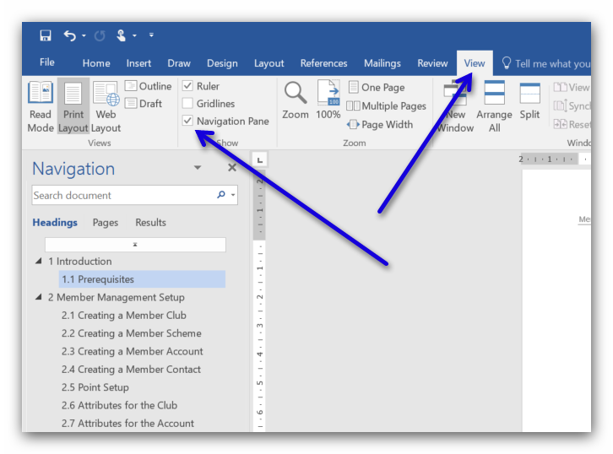

1. Please follow the demo script instructions in detail to make sure that your outcome will be the same as in the procedures
2. Member Management in LS BC

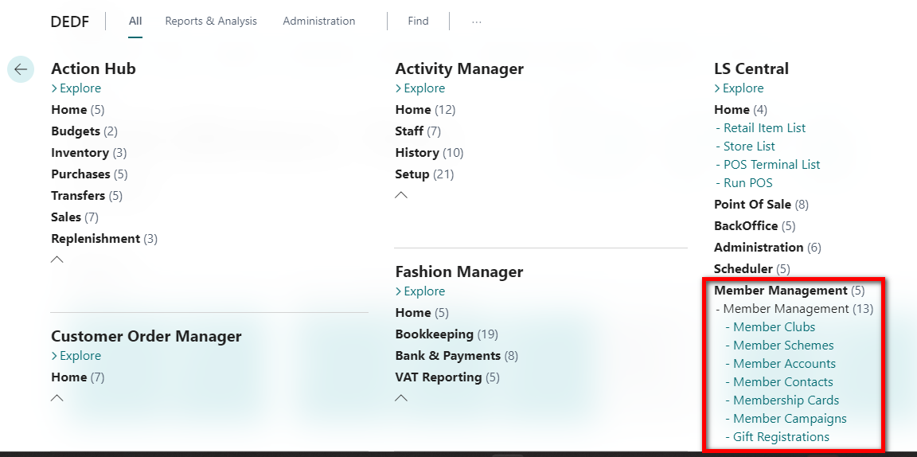

1. Member Management information  
   This Demo Script is intended to help the user to use and learn about Member Management.  
   For further information about Member Management read the Member Management Quick Guide which is shipped with LS BC. The on-line help with LS BC can be found by this link: http://help.lsbc.lsretail.com

# Member Management

This demo script is about Member Management in LS BC so by default it is assumed the user knows where to find the different menus.

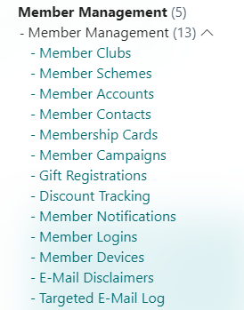 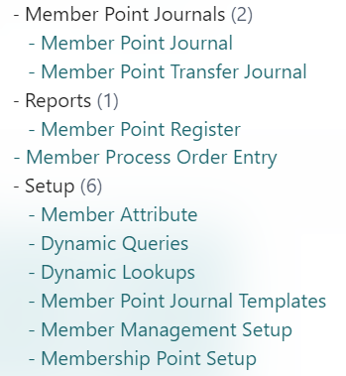

## Creating a Member Club

| **What to Do – Step by Step** | **Explanations** | **Talking Points** |
| --- | --- | --- |
| Select **Member Clubs** |  | Each company can have one, two or many Member Clubs |
| Click on the **New** action | The first thing to do is to create an entry for a new member club. When the member club has been created, member schemes for the club can be created |  |
| For the **General** Tab enter data for the following fields:  Code: **STAR**  Description: **Star Loyalty** **Club**  Club Type: **Loyalty Club**  For the **Numbering** Tab enter data for the following fields:  Card Registration: **Link to Contact** |  |  |
| For the **Point Calculation** Tab enter data for the following fields:  Point Expiration: **2Y**  Point Rounding Precision: **1,00**  Point Value: **1,00**  Period Calculation for.: **1Y**  Transferred Point Expiration:**1M**  Min Remain. Period for.: **1M**  Transfer Value Factor: **1,00**  Card Expiration: **1Y**  Unassigned Card Exp: **4W** |  |  |
| Create 3 new Number Series   * **SA-ACCOUNT** * **SC-CONTACT** * **ST-CARDS** | To create a new number series, select the dropdown arrow by the Number series fields    Then click on **New** for a new entry and finish filling in the relevant fields  Please remember to mark the Default Nos. field for each number series | When creating the number series take care to have their starting and ending numbers high enough to fulfill the company’s requirement. |
| Continue to fill out the fields for the **Numbering** Tab  Account No. Series: **SA-ACCOUNT**  Contact No. Series: S**C-CONTACT**  Card Setup Type: **Club**  Card No. Series: **ST-CARDS**  Reason Codes Accounts: **MR‑ACCOUNT**  Reason Codes Contacts: **MR‑CONTACT**  Reason Codes Cards: **M‑CARD** |  |  |
| Look at the **Statistics** fast pane |  | The Statistics tab will update information about the selected club |
| Look at the Member Schemes lines for the Club |  |  |
|  | The club STAR has been created, the next step is to create **New** Member Schemes |  |

## Creating a Member Scheme

| **What to Do – Step by Step** | **Explanations** | **Talking Points** |
| --- | --- | --- |
| Select **Member Scheme** |  | For every Member Club, it is possible to set up one, two or many Member Schemes |
| Click on the **New** button  For the **General** tab enter data for the following fields:  Code: **ST1-MARS**  Club Code: **STAR**  Description: **Star Mars** |  |  |
| For the **Upgrade** Tab enter data for the following fields:  Update Sequence: **1**  Buffer Days Before Expire: **15**  When Check for Upgrade: **Monthly** |  |  |
| Look at the **Numbering** tab | Default values for these fields come from the club it belongs to |  |
| Look at the **Statistics** tab | All number field have value 0 since no transactions have been posted yet  The Statistics tab is for statistical information for the scheme |  |
| Create another Scheme for club STAR  The Code for the scheme: **ST2‑VENUS**  Club Code: **STAR**  Description: **Star Venus** |  | Schemes can be created by two methods   * In Member Scheme Card * In Member Club Lines, New for a new line |
| For the **Upgrade** tab:  Update Sequence: **2**  Buffer Days Before Expire:**15**  Min. Point for Upgrade: **1500**  When Check for Upgrade: **Monthly**  Point Limit for Downgrade: **1200** | **Note:** The ST2-VENUS Scheme is higher than the ST1-MARS scheme. This can be seen by the Update Sequence value. ST1‑MARS has no setup for Point values since it is the club’s basic scheme  **Note:** For a Club member to be upgraded from ST1-MARS to ST2‑VENUS he needs to collect 1.500 points in the actual period. A ST2-VENUS club member needs to receive 1.200 points in the active period to stay in the club and not to be downgraded |  |
| Select **Member Club**  Select the **STAR** club  Look at the **lines** for the club | The new schemes are displayed | When a user deletes a Scheme line here the Scheme is deleted permanently |
| For the Default Scheme field enter value **ST1‑MARS** | Scheme ST-MARS is the default Scheme for every new account starting in the Club |  |
|  | The next step is to create the member accounts for the club |  |

## Creating a Member Account

| **What to Do – Step by Step** | **Explanations** | **Talking Points** |
| --- | --- | --- |
| Select **Member Accounts** |  |  |
| Click on the **New** button  Click on the **Tab** button | A new window opens; the user must select the club the account is linked to |  |
| Select the **STAR** club  Click on the **OK** button |  |  |
| For the **General** tab enter data for the following fields:  Description: Account: **Bill and Jo**  Account Type: **Company**  Scheme Code: **ST1-MARS** | The No is created automatically from the number series setup for the selected Club | Account Type has 3 possibilities:    The Account Type *Private* can only have one Contact number |
| Create **two** other Accounts for Member Club STAR  Names: **Alice Franklin** and **Carl Cantley**  One with Account Type Private and the other as Family | On Member Accounts you can see new accounts | New Member Accounts belong to the scheme ST1-MARS by default |
| Close the windows |  |  |
| Select **Member Club**  Select entry **STAR** | The field No. of Accounts has been updated according to the new member accounts entries | The same information for No. of Accounts has been updated for the Scheme to which the accounts belong    If all new accounts belong to the scheme ST1-MARS then the files No. of Accounts should show 3 |
| Click on the **Club** button  Select **Accounts** |  |  |
| Look at the window | This will display all the accounts for the selected club STAR  Member Accounts for club STAR should be three now in total |  |
| Close the windows  Select **Member Account** | This lists all accounts for all Clubs | One more method to view Accounts is to select Member Scheme, button Scheme, Accounts. This will list all accounts for the selected Member Scheme. |

## Creating a Member Contact

| **What to Do – Step by Step** | **Explanations** | **Talking Points** |
| --- | --- | --- |
| Select Member Contact |  | Member Contacts are created for Member Accounts |
| Click on the **New** button  For the field **Account No.** select **SA000001**  Click on the **TAB** button twice | The Contact No. code is automatically filled out. This number is from a number series which is set up in Member Club STAR |  |
| Fill out information for the other fields in the window  Not all fields are mandatory |  | The first contact for an account will always be the Main Contact. Every account needs to have one Main Contact.  Main Contact can be changed later to another contact. |
| Create more contacts as you want  Close the window |  |  |
| Select Member Club **STAR** | Relevant information about Contacts have been updated |  |
| Look at Member Scheme **ST1-MARS** | The Scheme Card shows how many Accounts and Contacts belong to the selected Scheme |  |

## Point Setup

| **What to Do – Step by Step** | **Explanations** | **Talking Points** |
| --- | --- | --- |
| Select **Member Club**  Select **STAR** and |  | It is necessary to set up the rule for point calculation in the system.  At least one rule must exist per club. |
| Select **Point Setup** |  |  |
| Create a new entry which has:  Item Filter Type: **All**  Customer Filter Type: **All**  Base Calculation on: **Amount**  Unit Rate: **10,00**  Points Type: **Award Points**  Points:**1,00** | **Note:**   * It is possible to have many entries in Membership Point Setup for example where Item Filter Type can be different Category Groups * The options for the Item Filter Type field are * Base Calculation on can be *Amount* or *Quantity*. This value gives a different meaning for the field Unit Rate | Points Type can be:     * Award Points are points earned through sale * Other Points are points that are bought or transferred |
| Close the windows |  |  |
| Select **Member Scheme**  Open card for **ST1-MARS**  Select Tab **Actions >> Scheme**  Select action **Point Setup** | The same Membership Point Setup window opens but here the user can define the Point calculation for the selected scheme.  The system always first looks for Point Setup for the Scheme and if nothing exists then it looks for the Club’s Point Setup | It is not necessary to set up Point Setup for member club, member scheme and member account |

## Attributes for Club

| **What to Do – Step by Step** | **Explanations** | **Talking Points** |
| --- | --- | --- |
| Select **Member Club**  Select the entry **STAR**  Select **Edit** to open the club card |  | Every club can have its own set of attributes.  Attributes are extra information for the club.  Attributes are of different Type and with different Lookup Type.  Some functions, for example Member Campaign and the Offers make use of the Attributes. |
| Select tab **Actions >> Club**  Select **Attribute Setup** |  |  |
| Select the **Dropdown arrow** by the Code field | Each club can have its Attributes. Attributes for a club can be one or many |  |
| Select the attributes **BIRTHDAY.**  Close the window |  |  |
| Search >> **Member Attributes** | Here are all the attributes that are set up for the Demo Data.  For further information about Attributes read the Member Management Quick Guide for LS BC. |  |

## Attributes for the Account

| **What to Do – Step by Step** | **Explanations** | **Talking Points** |
| --- | --- | --- |
| Select **Member Accounts**  Select Account number **SA000001** |  |  |
| Select the **Account** button  Select **Attributes Setup** |  |  |
| Be in **Member Account** Card  Select Account number **SA000001**  Select the **NAVIGATE** tab  Select **All Attributes** |  |  |
| Look at the window |  |  |

# General Functions

## Creating Cards

| **What to Do – Step by Step** | **Explanations** | **Talking Points** |
| --- | --- | --- |
| Select **Member Club**  Select the club **STAR** |  | Cards are either created for the Club or the Scheme. It depends on the Club’s setup.    The Star Club is set up so that cards are set up for the club. |
| Select the **Related function**  Select **Create Membership Cards** |  |  |
| Enter **20** for No of Cards  Click on the button **Create** |  |  |
| Select **All Cards**  Close the window | 20 new Cards numbers have been created and have the status Free |  |
| Select **Active Cards** | No cards exist on this list since no cards have been assigned for this club yet | The next step is to assign cards to accounts |

## Assigning Cards

| **What to Do – Step by Step** | **Explanations** | **Talking Points** |
| --- | --- | --- |
| Select **Membership Cards**  Select one free card with Club Code **STAR** |  |  |
| Assign account no. **SA000001** to it  Press **Enter**  Press **OK** | The contact data is populated automatically if account has only one contact created |  |

## Active Cards

| **What to Do – Step by Step** | **Explanations** | **Talking Points** |
| --- | --- | --- |
| Select Member Club  Select Club **STAR** |  |  |
| Select **Active Cards** |  |  |
|  | This will show all active cards for the selected club |  |

## Blocking / Unblocking Accounts

| **What to Do – Step by Step** | **Explanations** | **Talking Points** |
| --- | --- | --- |
| Select **Member Accounts** |  | The user can block Account, Contacts and/or Cards  The method is the same or very similar. |
| Select the Account which is going to be blocked, for example No. SA000001 **Bill and Jo**  Place a check mark in the Blocked field |  |  |
| Select **CANCEL-MEM**  Select **OK** | A new window appears where the user chooses the Reason Code for this blocking |  |
| Look at theinformation | The system registers the reason for blocking, Date Blocked and Blocked By |  |
| Uncheck the **Blocked** field  Select **Yes**  Close the window | No check mark exists for the field    The account is no longer blocked |  |
| Select **Member Club**  Select club, **Cronus** or **Star**  Under the **Numbering** tabselect **Reason Codes Account** field with Dropdown arrow | Reason codes for blocking Accounts are set up here. It is possible to add more entries. Each club can have its own set of Reason codes for Blocking. |  |

## Member Point Journal

| **What to Do – Step by Step** | **Explanations** | **Talking Points** |
| --- | --- | --- |
| Search **Member Point Journal**  **Or** Select **Member Point Journal** |  | Member Points are normally created by POS Sales processes. Some procedures require the possibility to enter member points to accounts directly. The tool to do that is the Member Point Journal. |
| Select **Member** line  Click on the **OK** button |  | Member Point Journals are set up in **Member Point Journal Templates** |
|  | The Journal opens and is ready for data to be entered |  |
| **Insert 2 lines**  Type: **Sales**  Date: **your choice**  Document: **empty**  Account no: **SA000001**  Points: **25** and **50**  Point Type: **Award Points**  Point Value: **1,00** |  | By default this Journal has no data in the Document field so the user can enter the data. The Document field can be linked to a number series. This is set up for the Journal in Member Point Jnl. Templates. |
| Select the **Post** button |  |  |
| Select the button **Yes** or **No** |  |  |
|  | The journal has been posted |  |
| **More possibilities:**  Continue in the Member Point Journal  Create **four entries** of different Types  Use the Types:   * Redemption * Pos. Adjustment * Neg. Adjustment * Sales   For more information look at the lines in the example | Note that the last line has Point Value 2,0 which increases the Total Value for that line. The Total Value will be posting value which has nothing to do with the posted points for the account.  Type:   * **Sales**: Increases Issued Points and Balance * **Redemption**: Decreases Used Points and Balance * **Pos. Adjustment**: Increases Issued Points and Balance * **Neg. Adjustment**: Decreases Used Points and Balance   The Member Point Entries after the Journal has been posted: |  |
| **Post** the new Journal | Chapter 3.8 shows how to view at the Member Point Entries for a club/scheme/account |  |

## Member Point Transfer Journal

| **What to Do – Step by Step** | **Explanations** | **Talking Points** |
| --- | --- | --- |
| Search **Member Point Transfer Journals** |  | The Transfer Journal is very like the Member Point journal but here the Transfer to Account is in the Journal Line as well. |
| Create one line with:  Account No: **SA000001**  Transfer to Account No: **SA000002**  Points: **18** |  | It is only possible to transfer points between accounts in the same club. |
| Select the **Post** button |  |  |
| Select the **Yes** button for Posting  The Journal has been posted | Chapter 3.8 shows how to look at the entries for club/scheme/account | The club’s setup for Transfer points determines how much of the transferred points are transferred. Transferred points can lose their value to the new account. See Chapter 3.7. |

## Transfer Value Factor

| **What to Do – Step by Step** | **Explanations** | **Talking Points** |
| --- | --- | --- |
| Select **Member Club**  Select the club **STAR**  Select **Point Calculation**  Look at the **Transfer Value Factor** field |  | The Transfer Value Factor gives the option to decrease the point’s value to the transferred account.  Transfer Value Factor is set up per club in the system. |
| Change the value to **0.8**  Close the window |  |  |
| search **Member Point Transfer Journals** |  |  |
| Create a new entry  Account No: **SA000001**  Document No**: X765**  Transfer To Account No: **SA000003**  Points: **10** | **Note**: This Journal is different from the Transfer Journal in chapter 3.6. Here the Transfer Factor is 0.8 but was 1.0. The system will withdraw 10 points from account SA000001 and add 8 points to account SA000003  **Note:** This time a value was entered to the Document No. field but that is optional |  |
| **Post** the Journal |  |  |

## Member Point Entries

| **What to Do – Step by Step** | **Explanations** | **Talking Points** |
| --- | --- | --- |
| Select **Member Account**  Select Account **SA000001** |  | All transactions for points are registered and kept in the system. Point transactions are viewed in Member Point Entries. |
| Current member points status is visible on statistics pane on the right side of the account card |  |  |
| Select **Issued Award Points** | Here all entries for the selected Account are displayed | The system keeps lots of information about the transaction with each entry. |
| Close the window  Select Member Account **SA000002**  Click on the **Account** button  Select **Issued Other Points** | In this script only one entry has been created for account SA000002 |  |
| Close the windows  Select **Member Club**  Select the entry **STAR**  Click on the **CLUB** button  Select **Total Issued Points** on statistics pane | This displays all Point entries for the club STAR |  |
| Close the windows  Select **Member Scheme**  Select the entry **ST1-MARS**  Click on the **RELATED** button  Select **ENTRIES >> Member Points**  Close the windows | This displays all Point entries for the scheme ST1-MARS |  |

## Member Point Statistics

| **What to Do – Step by Step** | **Explanations** | **Talking Points** |
| --- | --- | --- |
| Select the Member Club **STAR**  Select the **Statistics** tab  Look at the values | Here the total points for the club are displayed  The point status for club STAR is shown in the Balance field |  |
| Close the window  Select Member Scheme **ST1-MARS**  Select the **Statistics** tab  Look at the values | Here the Point Statistics are shown for the selected Member Scheme |  |
| Close the window  Select Member Account **SA000001**  Select the **Statistics** part  Look at the values |  |  |
| Close the window  Select Member Account **SA000002**  Select the **Statistics** part  Look at the values |  |  |

# POS Functions

## Points Generated by POS Sale

| **What to Do – Step by Step** | **Explanations** | **Talking Points** |
| --- | --- | --- |
| Be ready in the **POS client**  Use Store:**S001,** Terminal: **P001**  Logon with user ID **103**  No password is required |  | For more information about the POS client read the POS Demo Script LS Retail BC.  You can use other POS Setups if you prefer. |
| Press on the **Member Card** button |  | When a Club member comes to the store to buy some goods the cashier must ask him for his card and register it to the sale.  It does not matter when the member card number is registered to the sale, it can be in the beginning, at the end or somewhere between. |
| Enter **ST000004**  Press **Enter** | ST000001 is the card number for Member Account SA000004 Bill and Jo | The member card number can be entered by:   * Using Member Card Button and keying in the Member Card Number * Keying in the Member Card number and then pressing the Member Card button * Using the MSR reader to input the Member Card number * Using Member Contact option to search for the contact and add the member to the sale by that |
| Look at the information part | The card has been registered for this sale  In this example card ST000004 belongs to Member Account SA000001. This Member Account is Scheme ST1-MARS when the screenshot is taken but could be another scheme for the Demo Script user if the Upgrade / Downgrade action has been processed |  |
| Sell items **595393** and **ACC006** |  |  |
| Finish the sale, for example with tender type Cash  Look at the receipt for the sale | The receipt displays information about the Member Account, Issued points and more for this Member Account depending on the setup  The Points Balance can be different from this; it all depends on former transactions | This receipt prints information about Issued Points, Used Points and Point Balance. This can be changed in the setup for the club |
|  | Member Point Entries originated by the POS client are not valid in the Member Management system until the process Update Member Points has been processed  Process Update Member Points can be manually run in the Periodic Activities but it is usually set up in the LS Retail Scheduler |  |

## Points Used as Payment in the POS Sale

| **What to Do – Step by Step** | **Explanations** | **Talking Points** |
| --- | --- | --- |
| Be ready in the POS |  | Member Points can be used to pay with in the POS  For this to work the setup must be prepared correctly  This must be set up:   * Member Points must be set up as a Tender Type in the store * The Club must set up the correct Tender type for the field Member Point Tender * The POS must have a button for this Tender Type * The POS command must connect with currency for this use. For Example use LOY which then must be set up with the exchange rate for the Points |
| Enter card **ST000003** into the Input Panel  Press the **Member Card** button |  |  |
| Sell an item:   * **595393** |  |  |
| Press the **Total** button |  |  |
| Press the **Member Points** button |  |  |
| Press **Enter** | When Member Points button is pressed this is displayed:    The amount is the sales amount equal to the LOY Amount  It is the currency used with Member Points |  |
| The receipt is printed  The sale is finished | This sale issued 10 points and Used 10,000 points  The Points Balance can be different from this; it all depends on former transactions for this member account |  |

# Periodic Activities

## Upgrade / Downgrade Management

| **What to Do – Step by Step** | **Explanations** | **Talking Points** |
| --- | --- | --- |
| Select **Member Club**  Select **STAR** | The STAR Club has Two Member Schemes, ST1-MARS and ST2-VENUS.  Review the setup for the schemes specifically the points limit to be upgraded. Then check the point’s status and member entries for each Member Account. | When a new member account is created is always put in to a default scheme. For the STAR club this scheme is the ST1-MARS one.  Member Accounts then may be moved to other schemes with a periodic job Upgrade/ Downgrade Management.  The job changes the scheme for accounts depending on:   * the Points issues for the member in a given period * The setup for the schemes about how many points there has be as the limit for being moved up or down a scheme |
| Select **Member Proces Order Entries**  Select **Upgrade/Downgrade Management** | This job checks all active Member Accounts in the system | Upgrade/Downgrade is a job which checks for every account in the system if it should be upgraded or downgraded to another scheme.  What it does is:   * Checks the account’s date in the field **Next Check for Update** * Checks the setup of the Account’s Scheme and Club * When the Account fulfills the requirements, it changes the Account scheme   **Note:** that an account can be moved two levels; that is, it is possible to change the scheme from ST1-MARS to ST2-VENUS |
| Select the **Yes** button or enter **Y** |  |  |
| Look at the display | The process finishes with an information window  Example of this window: | The result here totally depends on the data for the member accounts and setup for the member schemes |
| Note | Remember:   * The club has the setup for Period Calculation for Upgrade. Upgrade/Downgrade function sums up the points per account for this time length and checks it with the setup for the Schemes to find out if an account should be moved to another scheme      * Each Scheme has the setup for the Points limit to be Upgraded or Downgraded |  |

## Expire Member Point Entries

| **What to Do – Step by Step** | **Explanations** | **Talking Points** |
| --- | --- | --- |
| Select **Expire Member Point Entries** |  |  |
| Click on **Yes** |  |  |

## Update Member Information

| **What to Do – Step by Step** | **Explanations** | **Talking Points** | |
| --- | --- | --- | --- |
| Select **Update Member Information** |  | When POS sales are posted, they are saved in the Transaction Register.  Transactions from the POS that are connected to the Member Management system need to be transferred and posted as Member Point Entries. The system has a special task to perform this. It is called Update Member Information. | |
|  | The work has been done    This process should have created Member Point Entries for the POS sale that have not yet been generated | Usually the action Update Member Information is run in the LS Retail Scheduler but it can be done manually as well | |
| Select **Member Club**  Select club **STAR**  Select **Total Issued Points** on statistics pane  Select  Look for the new entry generated by Update Member Information | Three new entries have been created from chapters 4.1 and 4.2. Two we can see on **Total issued Points** overview:    Issued points we can see on **Used Points** overview:    Entries generated by the POS and action Update Member Information have source type as POS Transaction and the Document No. is the Receipts slip number/receipt number  The points calculated for this transaction depend on the Sales Total and the Clubs Point Setup | |  |

# Member Campaign

## Creating Member Campaign

| **What to Do – Step by Step** | **Explanations** | **Talking Points** |
| --- | --- | --- |
| Open **LS Centrl / Member Management / Member Management**  Select **Member Campaign** |  | Member Management includes the possibility to set up Member Campaigns.  Each Campaign can only work for one club.  Members for the Campaign can be entered either manually or by a query.  Each Campaign generates an attribute which is then valid for the campaign’s members and can be used to trigger Offers and Promotions in the system.  When a POS sale is triggered by an offer with campaign’s attribute the system generates Attribute Entries.  The Attribute Entries are a source of information to log actual sales the campaign generated. |
| Click on **New** for a new campaign  Enter information for these fields:  **Description:** STAR campaign  **Club Code:** STAR  **Starting Date:** the first day of the current month  **Ending Date:** the last day of the current month | The system fills out the No. of the campaign automatically from the Campaign No. Series  It is important to have the Starting and Ending Dates correct and valid for the time this is processed. | The number series for campaign number are configured in the Member Management Setup |
| Select **Query Line**  Select Line Type **Query**  and  select Query Id **All** |  | This example is using a Query already in the Demo data to create the members for the Campaign.  Campaign Members can be created manually as well |
| Click on tab **ACTIONS**  Select **Run Query** |  |  |
| Select **Yes** |  |  |
| Look at the Lines | Three new lines have been created and are now members of this Member Campaign.  These lines include all the members of the STAR club |  |
| Press the **Enable** button |  |  |
| Look at the screen | * The Status of the query is now Enabled * The Field Attribute Created is checked * The Enable button changed to Disable   The system did some activities to the data at the same time the campaign was created. Next chapter explains what was done | The Enable function checked the Attribute Created field. This field can be enabled manually before the campaign is enabled when needed. |
|  | The campaign is created and ready in the system |  |

## The Campaign’s Attribute

| **What to Do – Step by Step** | **Explanations** | **Talking Points** |
| --- | --- | --- |
|  | This is a continuous chapter of chapter 6.1 |  |
| Select **Member Campaign**  Select the **Cronus campaign**  Make a note about the **No** of the campaign. The Scripts No. is C00001  Close the window | The Demo Script’s campaign No. is C00001 |  |
| Select **LS Central/Member Management/Setup**  Select **Member Attributes** |  |  |
| Look at the window  Close the window | One of the Member Attributes is C00001 which is the same number as the Member Campaign created in the previous chapter | The Member Attribute is created:   * When the Member Campaign is enabled   or   * When the Create Attribute is manually processed |
| Search **Member Attribute** | C00001 will be found in Member Attribute. |  |

## Total Offer and Campaign Attribute

| **What to Do – Step by Step** | **Explanations** | **Talking Points** |
| --- | --- | --- |
| Select **Departments/LS Central/Member Management/Offers**  Select **Total Discount Offer** |  | For more information about check out the Offers Demo Script |
| Click on **New** to create a new offer  Enter **STAR Campaign** to the Description field | The No. is the next free number for the Offers, not necessarily the same in your data and in this script | This example is going to:   * Create a Total Offer with the new attribute as a trigger * Post a POS sale for a member with the campaign’s attribute * Process Update Member Information that creates the Member Point Entries and Campaign Attribute Entries   Campaign Attribute Entries are the topic of next chapter |
| Select the **Triggers** section  Enter **C00001** into the Member Attribute field  Enter **Yes** into Member Attribute Value | The Member Attribute Value gets value Yes when the Member Attribute is entered. If not please make sure it is **Yes** |  |
| Select the **Benefits** section  Create a line with:   * Type **Discount** * Value Type **%** * Value **10** |  |  |
| For the **Lines** create one line with:   * Type **Item Category** * No as **CRMT** |  |  |
| Click on the **Enable** button  Close the window | The Status of this offer is Enabled  The Total Offer is ready |  |
| Be ready in the POS  Press the **Member Card** Button  Enter **ST000003** and press **Enter**  Sell item **525939**  Press **Total** | Card number ST000003 is the card number for Member Account SA000001 Bill and Jo. This Member Account is part of our campaign and has the new attribute C00001  Pressing Total triggered 10% discount for this sale since   * This sale has Attribute C00001 which comes from the Member Account. * The item sold is in Category CRMT * The Total Offer made in this chapter is set up to trigger Attribute C00001 and item in category CRMT |  |
| Finish the sale with **Cash**  **Logoff the POS** since this chapter does not need it more | The receipt for the sale is printed and the sale is posted |  |
| Select **Departments/LS Central/Member Management/Periodic Activities**  Select **Update Member Information** | Update Member Information is processed and delivers this window    Read next chapter to learn more about the Campaign’s Attribute Entries |  |

## Campaign’s Attribute Entries

| **What to Do – Step by Step** | **Explanations** | **Talking Points** |
| --- | --- | --- |
| Select **Member Campaign**  Select Campaign **C00001** |  |  |
| Select **Attribute Entries** |  |  |
| Look at the window | Here all POS sales which have been triggered with the campaign’s attribute are listed. These may have been triggered by different Offers.  This is a source of information about the sales connected to the selected Member Campaign. |  |
| Close the windows  Select **Departments/LS Central/Member Management/Offers**  Select **Total Discount Offer**  Find the Offer created earlier  Click on the **Disable** button | The Status of the Offer should now be Disabled    This offer is now in status Disabled |  |

# Member Management with Offers

Offers can be triggered to work only for sales that include members.

With this is possible to create offers as:

* All members in club Star get 10% discount of all items
* All members in club Star get 50% discount of drinks at happy hours’ time
* All gold members in club Star discount for a specific item
* All members in club Star get a gift item when they are shopping on their birthday
* Members in a specific area get a discount next month
* Members will get three times more points than usually of all CRMT items if they shop next week
* and so many more options

The triggers setup in the offers can be

* The club
* The club’s scheme
* Selected attributes for member accounts/contacts
* Members in a specific member campaign

More information about how offers and member management work together is in the Offers Demo Script available for LS BC.